Proposal of the
Four-part Humanitarian Matching Grant Project
conceived by the
Rotary Club Pilsen and the Rotaract Club Pilsen,
both District 2240 – Czech and Slovak Republics,
in friendly cooperation with the
Rotary Club Birmingham, AL, USA, District 6860

INTRODUCTION - BACKGROUND
Based on historical experiences – namely the liberation of Pilsen, the Capital of West Bohemia, by the American Army of Gen. Patton in May, 1945, the 60th anniversary of which has been celebrated in 2005 in closest cooperation with the US Embassy in Prague, namely with the US Ambassador – H. E. Mr. William Cabaniss, a new partnership between the cities of Pilsen, Czech Republic, Europe, and Birmingham, Alabama, USA, has been tied up in May, 2005.
Thanks to the inspiration by Mr. W. Cabaniss, still RC Birmingham member also the local Rotary Clubs, i. e. RC Pilsen, Czech Republic, D. 2240, and Birmingham, AL, USA, D. 6860 decided to cooperate friendly in the framework of this City Partnership and to contribute to a friendly mutual understanding. Two delegations of the RC Birmingham visited therefore in 2005 Pilsen: 20 members in May, and 25 members in October, this time together with the Club President for 2005/06 Jim Hughey, both visits under auspices and in personal presence of H. E. Mr. William Cabaniss, being “the father” of this partnership. Both sides agreed upon to be helpful namely on the social-humanitarian field where support is needed in more spheres, still neglected like a sad inheritance of the 40 years long totalitarian rule of the Communists.
According to a preliminary agreement, the members of the Rotary Club of Pilsen, together with the ROTARACT Club of Pilsen, decided therefore to help those who need it the most: destitute children, mentally affected children, or hearing impaired children. It´s true that the respective institutes exist in the City of Pilsen directly or in its closest neighborhood. But all of them are asking urgently – as stated by Pilsner active Rotaractors – for different material help. The Rotaractors offered their support already in recent years helping not only materially, but also psychically. E. g. in the Institute for the destitute children aged 2 – 6 years there is steadily a lack of the child´s intimate personal contact with an adult if the parents don´t exist, although the nurses there are doing all their best to alleviate the deprivate childrens´ situation. In this way also the RTC members are learning how essential it is for a child to have close his caring mother or father, to have his family, to have his save home.
Rotarians of both Rotary Clubs decided therefore to support this important effort of Rotaractors on one side and of Rotarians on the other and conceived a four-part humanitarian Matching Grant project, covering four social institutes based directly in Pilsen or its close surroundings as follows:
Section 1:
COMPENSATORY AIDS FOR HEARING IMPAIRED CHILDREN IN A SPECIALIZED KINDERGARTEN
Introduction
Cooperation of the Rotary Club Pilsen with the Special school for hearing impaired children in Pilsen has been accomplished already immediately after the Club´s reestablishment in 1991. It enabled repeated exchange visits of aurally handicapped children with those from the Oak Lodge School, London, being under the care of the Rotary Club of London, Great Britain. The RTC Pilsen together with the RC Pilsen are interested now to tie up for further cooperation – mainly by purchasing compensatory and therapeutical aids on one side and helping with integration of those handicapped into healthy society on the other.
The RTC Pilsen decided therefore to prepare in autumn 2005 for the children a cele-bration of St. Nicolas Day. Another possibility of cooperation consists in organizing a National Championship for hearing impaired youth in floorball.
Presentation of the Special school for hearing impaired children
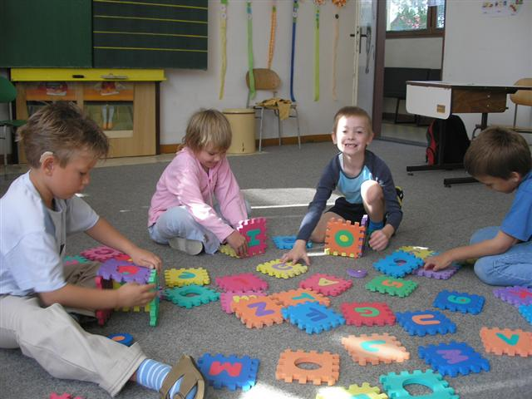
The Special school for hearing impaired children has been established in 1914 already. In 1973 it has moved to its current position in Pilsen – Doubravka. It consists of the following:
- special facility for children, who need individual attitude and care,
- kindergarten and basic school for deaf children or for children with defects of perception and concentration,
- special pedagogical center,
Picture 1 – Hearing impaired children
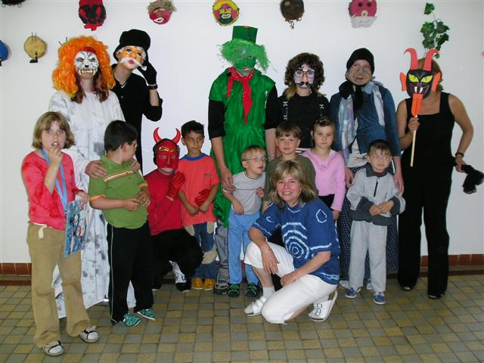
- hostel for children from further parts other communities in the Pilsen and Karlovy Vary regions,
- school providing education to deaf children with special methods,
- school where the education is led as in normal basic schools.

To the main activities of the school belongs qualified help for children with a hearing handicap, with speaking problems or with defects of sensory perception and for children, who need individual working approach, with specific educational problems. Simultaneously the school is helping parents to learn and understand correctly the world of their children and other schools with correct diagnostics of these children.
Picture 2 - Hearing impaired children
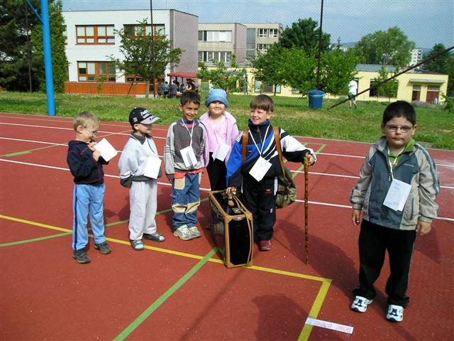
Special kindergarten is attended by children from the age of 3 with harder or lighter hearing handicap, harder speaking handicap or combination of both (physically handicapped, problems with perception or concentration). In the kindergarten an individual attitude and spe-cial methods are being used during communication – total method is being employed (oral speak-ing, sign language and written form of the language). The video programs are used to diffuse word power. Besides that, children are attending swimming courses, rehabilitation gymnastics and hippo-therapy. Chirophonic massages are also applied here. Children have also possibilities to visit several cultural venues.
Introduction of the sub-project
For a development of fine and rough motion abilities, imagination, touch, orientation in space, as well as for development of intellectual and aesthetical capacities of those handicapped it is necessary to purchase compensatory and therapeutic aids for children in kindergarten.
Picture 3– Hearing impaired children
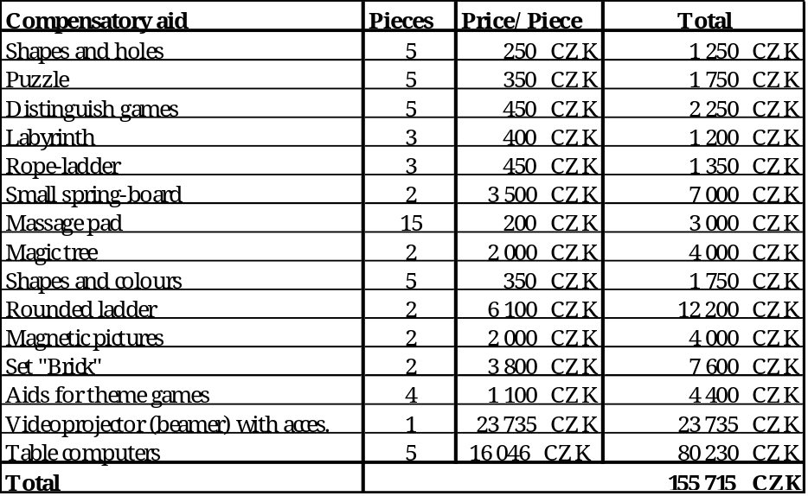
All these aids will support handicapped children to strengthen their motion ability as well as their spoken language habits, although the teaching process of aurally handicapped children to speak is very long and difficult. The speech is taught on the basis of conditioned reflex because the position of lips and tongue is created unnaturally. Using a mirror, the teachers are setting up the right position of lips and tongue and the strength of out-breathed air so that a word can be heard. Aural handicap is almost always accompanied by the balance disorder. The video-projectors (beamers) with the screens and all six table computers will be used in the classroom as a tool to teach the sign language better. Together with a computer and special software a projector can offer a bigger image of how every expression should be shown correctly. In this way the speed of learning the sign language will be improved.
Section 2 :
SANITARY AND COMPENSATORY AIDS FOR MENTALLY AFFECTED CHILDREN AT THE SOCIAL-SERVICES HOUSE „NOVÁČEK“
Introduction
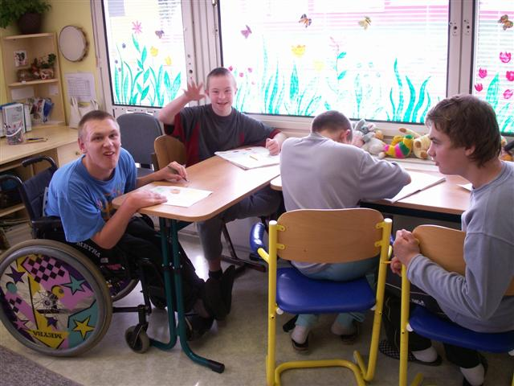
In the Rotary year 2005/06, a new humanitarian cooperation is being started between the Rotary Club Pilsen and the Social-Service House for mentally affected children and youth “Nováček”.
Presentation of “Nováček”
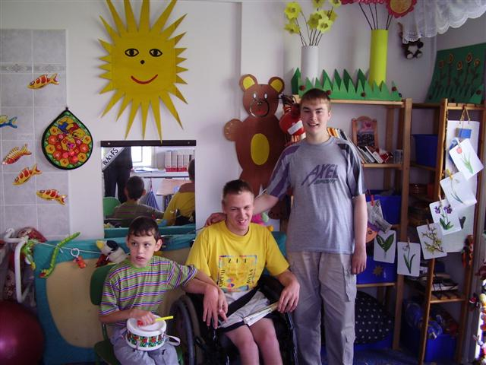
The Social-Service House for mentally affected children and youth “Nováček”¨ (hereinafter only: NOVÁČEK) has been established in Pilsen in 2000 and is located in a former Kindergarten, in Rabštejnská 29, 323 00 Pilsen. It is an allowance organization that fall within the Municipal House for Social Services in Pilsen having its seat on the following address : Klatovská 90, 301 00 – Pilsen, Czech Republic.
Picture 4 – MENTALLY AFFECTED CHILDREN
Nováček capacity counts 44 places designated for clients between the ages of 3 to 27 years. The House is divided into two main departments:
- Nursing department is aimed at mentally heavily handicapped children with combined abnormalities. There are cared mostly recumbent children in this department, who need health care and treatment primarily. Capacity of this department is 12 places.
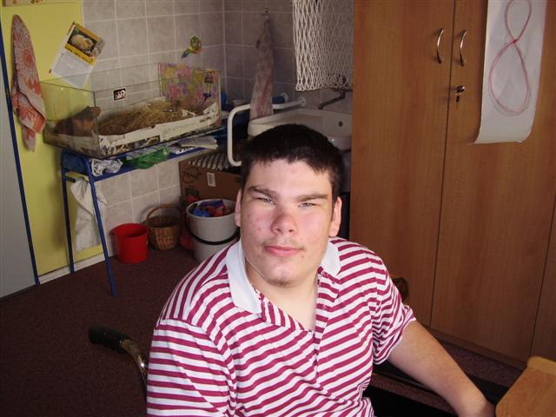
- Education department is aimed at mobile and wheelchair bound children, whose dys-phrenia is in the range between middle and hard mental retardation. Capacity of this department is 32 places.
Picture 5 – MENTALLY AFECTED CHILDREN
There is a special school in the NOVÁČEK area that most of these children are visiting. Those who didn´t accomplish their mandatory school visit or are not disposed to attend classes at the special school, they work in ergo-therapeutic workrooms. There they work with various materials – ceramics, paper, fabrics, wool, silk, colors, glue, etc. To improve their psychical capacity they visit a special room designed for relaxation. Various cultural events, e.g. theater performances, games, sport activities, wandering in the nature etc. are organized for children.
Picture 6 – MENTALLY AFFECTED CHILDREN

Introduction of the sub-project
It´s the aim of this sub-project to care – in close cooperation between the Rotary Club of Pilsen with its foreign partner Club – for different sanitary aids which could be quite helpful, e.g.:
- anti-decubital mattresses to avoid creation of decubitus on recumbent children
- air moisteners to limit children’s mucosa drying-out especially in winter period
- air cleaners to inhibit further dissemination of respiratory infections
- Compensatory aids contributing to develop fine and rough motion ability and to improve intellectual capacity and motion ability. These aids can also support development of imagination and improvement of hearing, sight and touch perception.
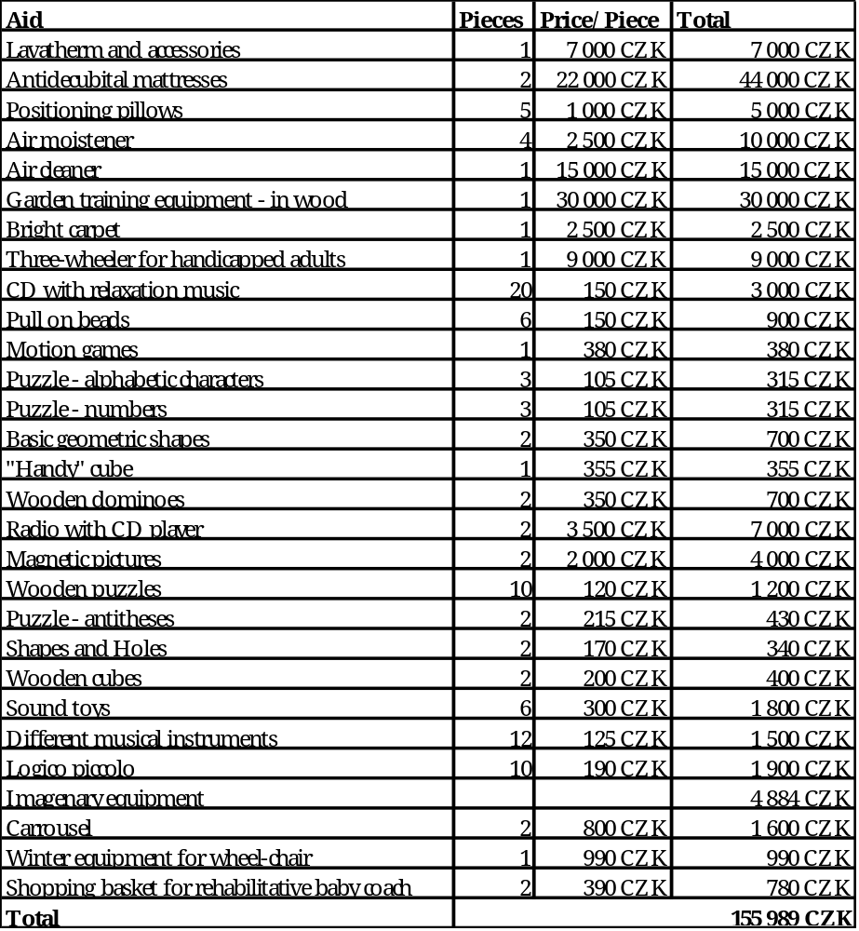
Section 3 :

BABY BEDS FOR CHILDREN’S HOME AT TRNOVÁ
Introduction
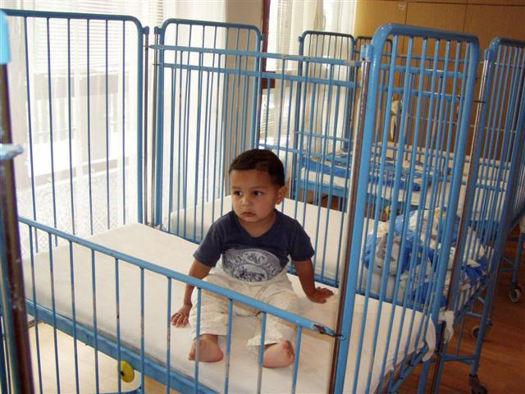
A cooperation between the RTC Pilsen and the Abandoned Children’s Home at the Trnová village (Pilsen-North, hereinafter only: the Home) started in 2002. In that year the RTC concluded successfully its long-standing cooperation with another Children’s Home called DOMINO in Pilsen and its clients and decided to start a cooperation with another organization, that was more in need for their help.
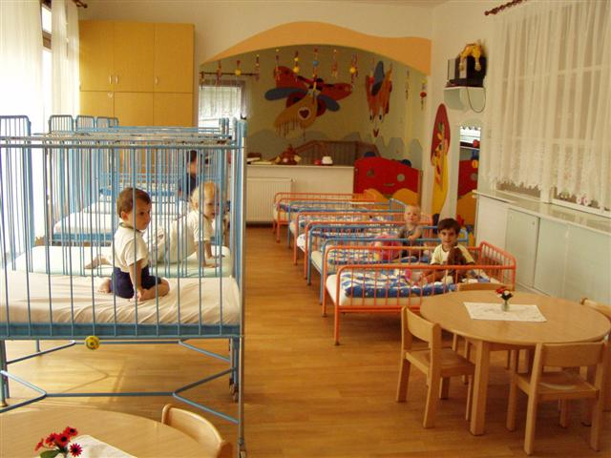
Since 2003 the RTC Pilsen has been organizing each autumn a “Music and Theater Rotaract Festival“, the proceeds of which go to the Home at Trnová. Thanks to this financial help it was possible to arrange a sea-trip for kids in 2003 and to purchase interior equipments in 2004. Also in November 2005, another year of this festival took place, and the RTC Pilsen members collected a respective amount of money, that will help again this year.
Picture 7 – Children’s home Trnová
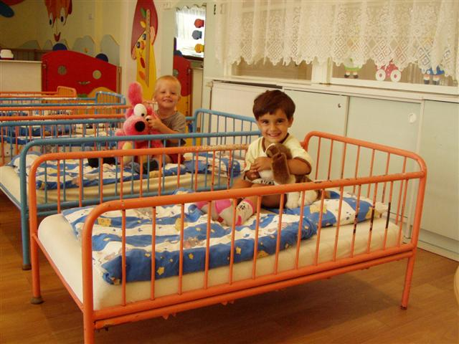
In 2003 RTC Pilsen organized in close cooperation with the RC Pilsen a Fashion Show. The proceeds, about 1,900 USD, were divided between the Home at Trnová and the EXODUS-organization, which helps handicapped people with their integration into society.
Picture 8 – Children’s home Trnová
Besides financial help, the RTC Pilsen and the RC Pilsen are preparing Kids-days in the garden of the Home. RC Pilsen provides sweets and prizes and RTC Pilsen helps with final accomplishment.

Presentation of the Abandoned Children’s Home at Trnová
This Home lies in the village Trnová located quite close to Pilsen. It has been established in 1951 like a social-medical institution in the framework of the Ministry for Public Health. It performs as a contributory organization having independent legal subjectivity. Its establisher is the Authority of the Pilsen Region.
Picture 9 – Children’s home Trnová
The Home takes medical and educational care for 35 kids in the age between 1-6 years. which is a full capacity of the Home, but it treats usually much more children needed. Sometimes the children having more than 6 years still stay there, too.
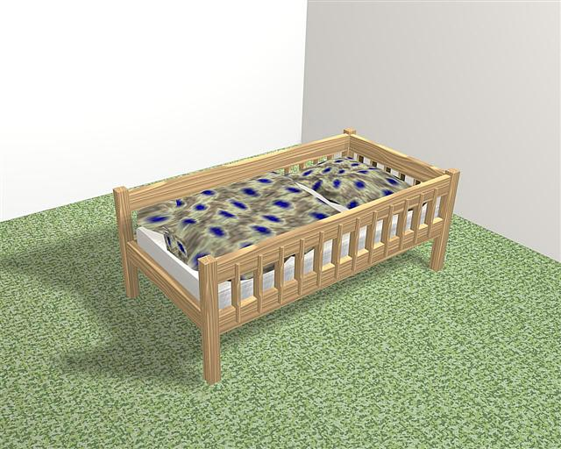
The target group are children with a certain level and type of threats and handicaps. Most of them are admitted from a socially risky background. Besides that many children have some health or mental problems or inborn evolutionary handicaps. Sometimes it is hard to distinguish the level of health and social handicap. The children are being placed here according to the court decision.
Generally we witness a cruel life destiny of these poor children. Some of them have their mother and father, or at least one of them, however they can´t, don´t want or arn´t able to take care for them.
In this Home the kids are in the care of nurses and foster mothers. They visit local kindergarten and special class at the Trnová village. Logopedic service and rehabilitation is provided to children directly in the Home with special pedagogical supervision. The main effort consists in making the stay of the children as short and agreeable as possible and to send them back to families, either to their own or to foster ones.
Picture 10 – New beds design
All these children have the same needs and rights as any other – love, safety, education, medical and social care and HOPE, on which everything depends. This hope has its real name – “a new family”. Nurses are trying to make the stay for children the most enjoyable as possible. They organize several activities, like zoo or theatre visits, summer holidays, birthday parties, games, etc.

Introduction of the sub-project
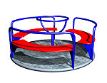
The main goal of this sub-project is to raise funds needed for production and installation of new wooden beds for the smallest kids, because current metal, partly damaged hospital beds are no longer adequate. We would like to swap them with the new wooden ones, which are in adequate execution and suit much better not only from the aesthetical point of view (the whole building was reconstructed recently and all interior equipments are in wood, to summon up family-like environment to children) but mainly because the present metal ones are technically insufficient. They are stale, in use for more than 20 years, unstable and noisy, they decay and the varnish exfoliates, which is also very unhygienic. The budget for 15 new beds (7 low ones and 8 tall ones) urgently needed is approx. CZK 147,000. This furniture in wood can be bought in the Czech Republic, where the obligatory certificate of safety of the product is guaranteed.
We would like also to supply garden equipment consisting of 1 carrousel in order to improve as much as possible the distraction of small children in the garden where they spend most of their free time. Certificate of safety of the product is guaranteed.
Picture 11 – Carrousel
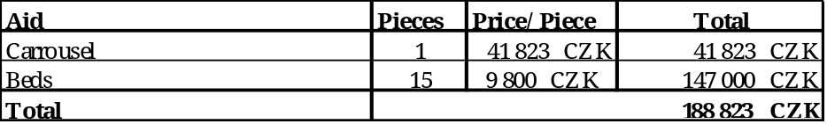
Section 4 :

Equipment of the club center of the „YOU AND ME“ association
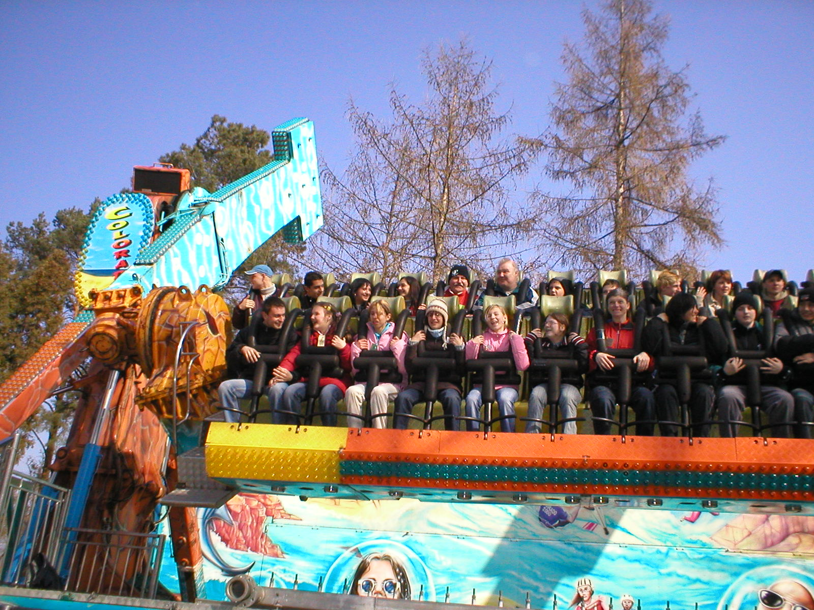
Introduction
In the Rotary year 2005/06, a new humanitarian cooperation is being started between the Rotary Club Pilsen and the „YOU AND ME“ Association (founded in 2005) as Rotary Club Pilsen is involved in the production of music CD of the musical chore “HVĚZDIČKY” (little stars).

Presentation of the You and Me – Association to support the handicapped people
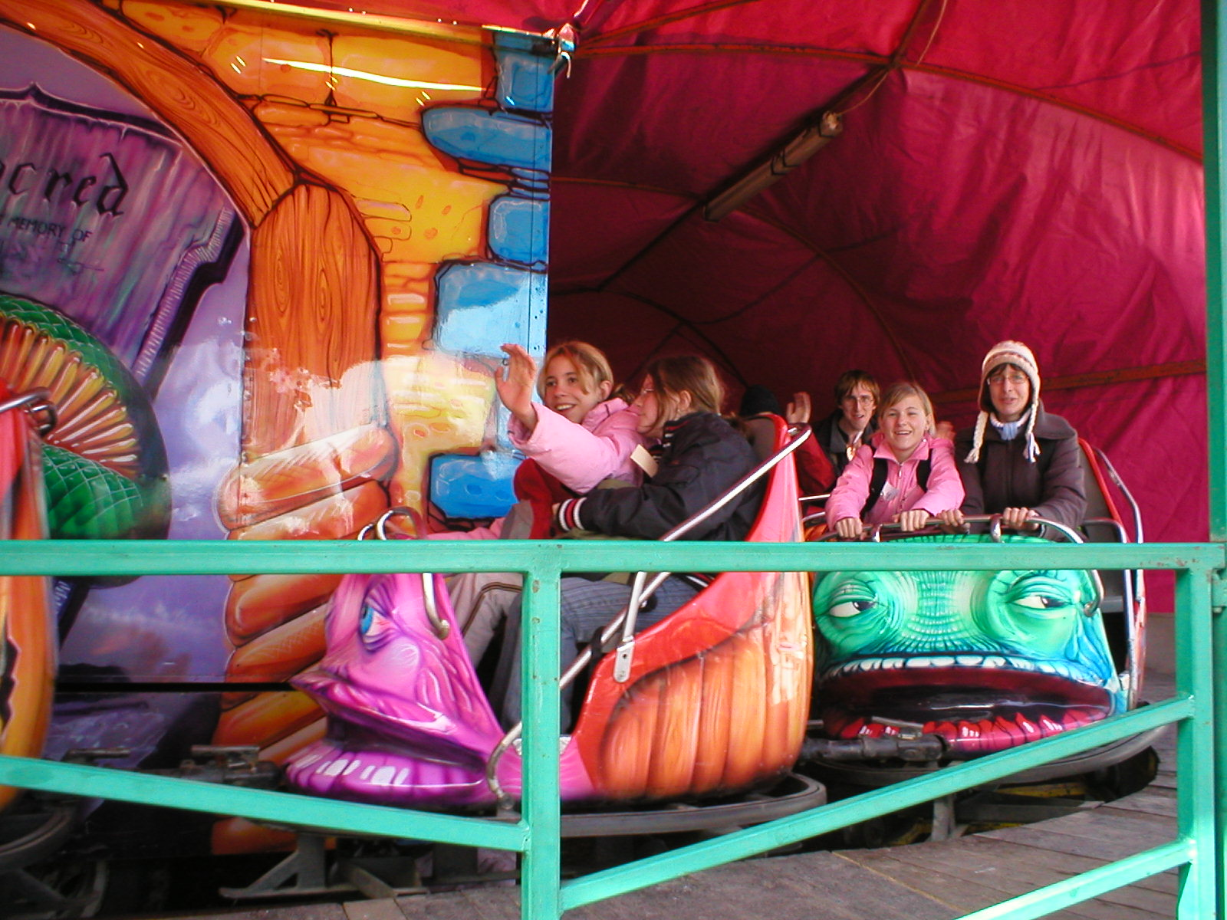
The goal of „YOU AND ME“ association is to support the integartion of children and adult citizens with physical and other disabilities into our society. The association supports the club center. “ROLNIČKA” (jingle-bell), whose part is a singing choir “HVĚZDIČKY (little stars). Children and teenagers meet in the centre to do various hobbies and activities. Children in the singing choir organize in (and around) Pilsen concerts for the public since 2005. They will participate in the Abilympic Games in Prague in May this year. In August 2006 children from the singing choir are planning to go to a summer camp in a barrier-free camp center Nový Rybník.
Picture 12 – Children in amusement park
Picture 13 – Children in amusement park

Introduction of the sub-project
The main goal of this sub-project is to raise funds needed for the activities of the club center and singing choir the computer with multifunctional printer and fax, audio technics and other equipment (eg. Acupressure-bed, excersie-balls, etc.).
Music art will improve the quality of appearance of children because the appropriate audio equipment will increase the level of concerts and the children’s self-assurance that ,,they are like small stars”. The PC and with internet access will create an easier way to get information for children and to communicate with neighbourhood. The equipment for ceramic (figuline and various tools) and creative (temperas, watercolour, papers, templates, etc.) club activities will help the children to develop motoric skills, self-service and self-realisation.
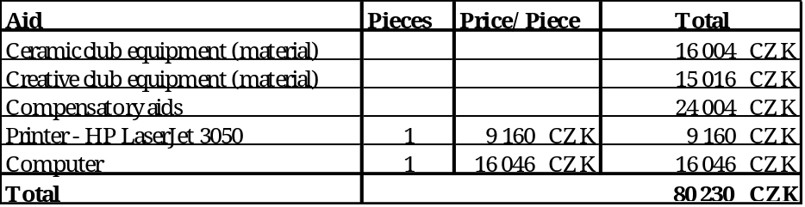

General Economic Preconditions
According to the documents presented to the Rotarians from the RC Birmingham during their recent visit to Pilsen in October 2005, they decided to support this Four-Parts Project by the amount of 10,000 US $. Therefore their President for 2005/06 Mr. Jim Hughey handed over to the RC Pilsen President Mr. Miroslav Pech a cheque for the amount of US $ 10,000, which has been highly appreciated.
RC Pilsen will receive the supporting amount of 4,000 US $ from the DDF available on the D. 2240 level for the year 2005-06. Demand has been presented to Mr. Otakar Veselý, the acting DG who accepted it.
Pilsner Rotarians are ready to contribute to this humanitarian project themselves from their much more modest funds by cca US $ 1,500.
To be able to accomplish this MG-project proposal up to its desired amount, it would be very welcome if the Rotary Foundation could contribute to the total amount needed by a respective Matching Grant.
Financial Summary:
Average exchange rate valid as for October / March, 2005/2006 : 1 US $ = 23,00 CZK
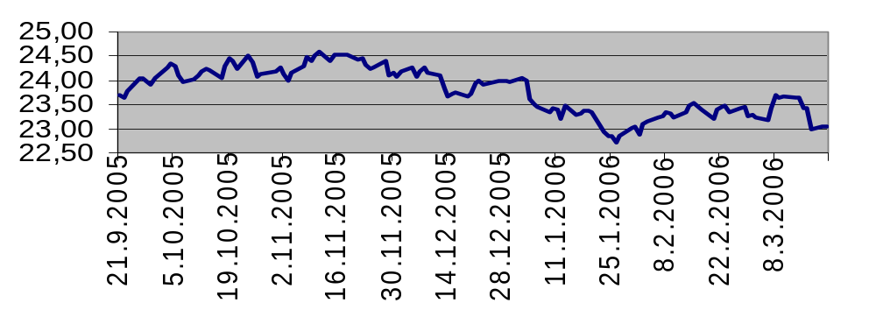

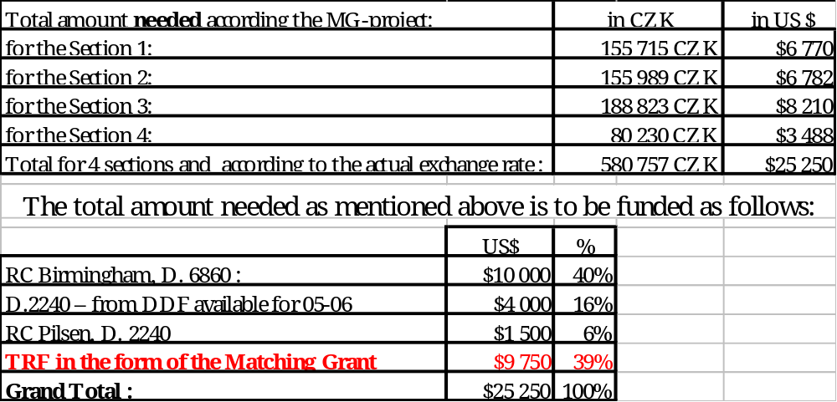
The easiest way how to care for the equipments needed and included into this project consists in purchasing them all from local sources in the Czech Republic, where all the goods needed are available from local producers or in retail shops and/or supermarkets. The price of the respective items are documented by preliminary pro-forma invoices from the most important suppliers enclosed to the MG-Project Application Form).
E n c l o s u r e s:
- Pro-forma invoice from Jan Vanecek – Computer equipment (+specifications) – 3 pcs.
- Pro-forma invoice from Truhlarstvi Roudna s. r. o. – Beds – 1 pc.
- Pro-forma invoice from PALIS Plzen – 1 pc.
Conclusion
All the MG-project partners are looking forward that a kind contribution by The Rotary Foundation in the form of a respective Matching Grant will enable to accomplish this four-part project so urgently needed in Pilsen, Czech Republic, for the benefit of handicapped and/or abandoned children.

. . . . . . . . . . . . . . . . . . . . . . . . . . . . . . . . . . . . . . . . . . . . . . . . . . . . . . . .
Miroslav P e c h Filip M r k v i č k a
President of the RC Pilsen 05/06 President of the RTC Pilsen 05/06
Pilsen, March ….. 2006

. . . . . . . . . . . . . . . . . . . . . . . . . . . .
Jim H u g h e y
President of the RC Birmingham for 05/06
Birmingham, March ….. 2006

